
Tecnura
https://revistas.udistrital.edu.co/ojs/index.php/Tecnura/issue/view/1253
DOI: https://doi.org/10.14483/22487638.xxxxx

INVESTIGACIÓN

Título en idioma original

Título en segundo idioma
Autor 11 y Autor 22

Fecha de Recepción: xx de xxxxxx de 202x Fecha de Aceptación: xx de xxxxxx de 202x
Cómo citar: A. B. Apellido1-Apellido2 and C. D. Apellido1-Apellido2, “Título original del ar- tículo,” Tecnura, vol. xx, no. xx, pp. xx–xx, 202x, https://doi.org/10.14483/22487638.xxxx

Resumen
Objetivo:

Métodología:
Resultados:
Conclusiones:

Palabras clave:

Abstract
Objective:
Methodology:
Results:
Conclusions:

Keywords:


¹Biografía corta. Filiación . Email: xxxxxxx@xxx.com
²Biografía corta. Filiación. Email: xxxxxxx@xxx.com

Introducción
Lorem ipsum dolor sit amet, consectetuer adipiscing elit. Ut purus elit, vestibulum ut, pla- cerat ac, adipiscing vitae, felis. Curabitur dictum gravida mauris. Nam arcu libero, nonummy eget, consectetuer id, vulputate a, magna. Donec vehicula augue eu neque. Pellentesque habi- tant morbi tristique senectus et netus et malesuada fames ac turpis egestas. Mauris ut leo. Cras viverra metus rhoncus sem. Nulla et lectus vestibulum urna fringilla ultrices. Phasellus eu tel- lus sit amet tortor gravida placerat. Integer sapien est, iaculis in, pretium quis, viverra ac, nunc. Praesent eget sem vel leo ultrices bibendum. Aenean faucibus. Morbi dolor nulla, malesuada eu, pulvinar at, mollis ac, nulla. Curabitur auctor semper nulla. Donec varius orci eget risus. Duis nibh mi, congue eu, accumsan eleifend, sagittis quis, diam. Duis eget orci sit amet orci dignissim rutrum.
Nam dui ligula, fringilla a, euismod sodales, sollicitudin vel, wisi. Morbi auctor lorem non justo. Nam lacus libero, pretium at, lobortis vitae, ultricies et, tellus. Donec aliquet, tortor sed accumsan bibendum, erat ligula aliquet magna, vitae ornare odio metus a mi. Morbi ac orci et nisl hendrerit mollis. Suspendisse ut massa. Cras nec ante. Pellentesque a nulla. Cum sociis natoque penatibus et magnis dis parturient montes, nascetur ridiculus mus. Aliquam tincidunt urna. Nulla ullamcorper vestibulum turpis. Pellentesque cursus luctus mauris.

Metodología
Nulla malesuada porttitor diam. Donec felis erat, congue non, volutpat at, tincidunt tri- stique, libero. Vivamus viverra fermentum felis. Donec nonummy pellentesque ante. Phasellus adipiscing semper elit. Proin fermentum massa ac quam. Sed diam turpis, molestie vitae, place- rat a, molestie nec, leo. Maecenas lacinia. Nam ipsum ligula, eleifend at, accumsan nec, suscipit a, ipsum. Morbi blandit ligula feugiat magna. Nunc eleifend consequat lorem. Sed lacinia nulla vitae enim. Pellentesque tincidunt purus vel magna. Integer non enim. Praesent euismod nunc eu purus. Donec bibendum quam in tellus. Nullam cursus pulvinar lectus. Donec et mi. Nam vulputate metus eu enim. Vestibulum pellentesque felis eu massa.
Quisque ullamcorper placerat ipsum. Cras nibh. Morbi vel justo vitae lacus tincidunt ultri- ces. Lorem ipsum dolor sit amet, consectetuer adipiscing elit. In hac habitasse platea dictumst. Integer tempus convallis augue. Etiam facilisis. Nunc elementum fermentum wisi. Aenean pla- cerat. Ut imperdiet, enim sed gravida sollicitudin, felis odio placerat quam, ac pulvinar elit purus eget enim. Nunc vitae tortor. Proin tempus nibh sit amet nisl. Vivamus quis tortor vitae risus porta vehicula.

Resultados
Fusce mauris. Vestibulum luctus nibh at lectus. Sed bibendum, nulla a faucibus semper, leo velit ultricies tellus, ac venenatis arcu wisi vel nisl. Vestibulum diam. Aliquam pellentesque, augue quis sagittis posuere, turpis lacus congue quam, in hendrerit risus eros eget felis. Mae- cenas eget erat in sapien mattis porttitor. Vestibulum porttitor. Nulla facilisi. Sed a turpis eu lacus commodo facilisis. Morbi fringilla, wisi in dignissim interdum, justo lectus sagittis dui, et vehicula libero dui cursus dui. Mauris tempor ligula sed lacus. Duis cursus enim ut augue. Cras ac magna. Cras nulla. Nulla egestas. Curabitur a leo. Quisque egestas wisi eget nunc. Nam feugiat lacus vel est. Curabitur consectetuer.
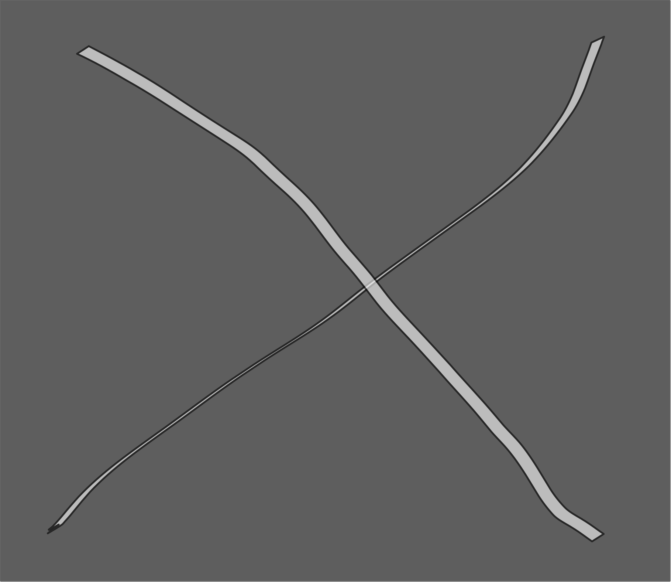
Figura 1. Ejemplo figura

Fuente: Autores.

Suspendisse vel felis. Ut lorem lorem, interdum eu, tincidunt sit amet, laoreet vitae, arcu. Aenean faucibus pede eu ante. Praesent enim elit, rutrum at, molestie non, nonummy vel, nisl. Ut lectus eros, malesuada sit amet, fermentum eu, sodales cursus, magna. Donec eu purus. Quisque vehicula, urna sed ultricies auctor, pede lorem egestas dui, et convallis elit erat sed

Tabla 1. Ejemplo de tabla genérica

TECHNICAL SPECIFICATIONS
PRODUCT | DIMENSIONS
RICE HUSK PARTICLEBOARD- HIDROPUL-400HTR | THICKNESS(mm) | LENGTH(m) | WIDTH(m)
RICE HUSK PARTICLEBOARD- HIDROPUL-400HTR | 15 | 2,44 | 1,83
RICE HUSK PARTICLEBOARD- HIDROPUL-400HTR | TOLERANCES
RICE HUSK PARTICLEBOARD- HIDROPUL-400HTR | THICKNESS(mm) | LENGTH(mm) | WIDTH(mm)
RICE HUSK PARTICLEBOARD- HIDROPUL-400HTR | +/- 0,2 | +/- 2 | +/- 2
PHYSICAL MECHANICAL PROPERTIES
PROPERTY | UNIT | VALUE
Density | Kg/m3 | 649,3
Internal Bond | N/mm2 | 0,7
M.O.E | N/mm2 | 2.140,8
M.O.R | N/mm2 | 15,67
Edge | N | 1.033,97
Side | N | 1.447,95
Fuente: Autores.

nulla. Donec luctus. Curabitur et nunc. Aliquam dolor odio, commodo pretium, ultricies non, pharetra in, velit. Integer arcu est, nonummy in, fermentum faucibus, egestas vel, odio.
Pellentesque habitant morbi tristique senectus et netus et malesuada fames ac turpis ege- stas. Donec odio elit, dictum in, hendrerit sit amet, egestas sed, leo. Praesent feugiat sapien aliquet odio. Integer vitae justo. Aliquam vestibulum fringilla lorem. Sed neque lectus, consec- tetuer at, consectetuer sed, eleifend ac, lectus. Nulla facilisi. Pellentesque eget lectus. Proin eu metus. Sed porttitor. In hac habitasse platea dictumst. Suspendisse eu lectus. Ut mi mi, lacinia sit amet, placerat et, mollis vitae, dui. Sed ante tellus, tristique ut, iaculis eu, malesuada ac, dui. Mauris nibh leo, facilisis non, adipiscing quis, ultrices a, dui.

Ejemplo de llamado de referencias (3), tabla 1 y figuras 1.

Conclusiones
Morbi luctus, wisi viverra faucibus pretium, nibh est placerat odio, nec commodo wisi enim eget quam. Quisque libero justo, consectetuer a, feugiat vitae, porttitor eu, libero. Suspendisse sed mauris vitae elit sollicitudin malesuada. Maecenas ultricies eros sit amet ante. Ut venenatis velit. Maecenas sed mi eget dui varius euismod. Phasellus aliquet volutpat odio. Vestibulum ante ipsum primis in faucibus orci luctus et ultrices posuere cubilia Curae; Pellentesque sit amet pede ac sem eleifend consectetuer. Nullam elementum, urna vel imperdiet sodales, elit ipsum pharetra ligula, ac pretium ante justo a nulla. Curabitur tristique arcu eu metus. Vestibulum

lectus. Proin mauris. Proin eu nunc eu urna hendrerit faucibus. Aliquam auctor, pede consequat laoreet varius, eros tellus scelerisque quam, pellentesque hendrerit ipsum dolor sed augue. Nulla nec lacus.

Referencias
- S. Almurashi, “Analysis of the most common spelling errors in English for Saudi students: A case study of foundation year students,” Getsempena English Edu. J., vol. 10, no. 1, pp. 73-89, 2023. https:
//doi.org/10.46244/geej.v10i1.2081 ↑
- F. Bustamante and E. Díaz, “Spelling error pattern in Spanish for word processing applications,” in Proc. 5th Int. Conf. Lang. Res. Eval., 2006, pp. 93-98. http://www.lrec-conf.org/proceedings/lrec2006/ pdf/119_pdf.pdf ↑
- S. Singh and A. Mahmood, “The NLP cookbook: Modern recipes for transformer based deep lear- ning architectures,” IEEE Access, vol. 9, pp. 68675-68702, 2021. https://doi.org/10.1109/ACCESS. 2021.3077350 ↑ 4
- A. Ferreira and S. Hernández. “Diseño e implementación de un corrector ortográfico dinámico para el sistema tutorial inteligente”, Rev. Signos, vol. 50, no. 95, pp. 385-407, 2017. http://dx.doi.org/10. 4067/S0718-09342017000300385 ↑
- A. San Mateo, “Un corpus de bigramas utilizado como corrector ortográfico y gramatical destinado a hablantes nativos de español,” Rev. Signos, vol. 49, no. 90, pp. 94-118, 2016. http://dx.doi.org/10. 4067/S0718-09342016000100005 ↑
- P. Gamallo and M. Garcia, “LinguaKit: A multilingual tool for linguistic analysis and information extraction,” Linguamatica, vol. 9, no. 1, pp.19-28, 2017. ↑
- G. Zomer and A. Frankenberg-Garcia, “Beyond grammatical error correction: Improving L1- in- fluenced research writing in English using pre-trained encoder-decoder models,” in Find. Assoc. Comp. Ling. EMNLP 2021 , 2021, pp. 2534-2540. https://doi.org/10.18653/v1/2021.findings-emnlp. 216 ↑
- B. Ünlütabak and O. Bal, “Theory of mind performance of large language models: A comparative analysis of Turkish and English,” Comp. Speech Lang., vol. 89, art. 101698, 2025. https://doi.org/10. 1016/j.csl.2024.101698 ↑
- M. Bijoy et al. “A transformer-based spelling error correction framework for Bangla and resource scarce Indic languages,” Comp. Speech https://doi.org/10.1016/j.csl.2024.101703 ↑
- E. Puerto, J. Aguilar, R. Vargas, and J. Reyes, “An Ar2p deep learning architecture for the discovery and the selection of features,” Neural Process. Letters, vol. 50, no. 1, pp. 623-643, 2019. https://doi.org/ 10.1007/s11063-019-10062-4 ↑
- E. Puerto, and J. Aguilar and A. Pinto, “Automatic spell-checking system for Spanish based on the Ar2p neural network model,” Computers, vol. 13, no. 13, art. 76, 2024. https://doi.org/10.3390/ computers13030076 ↑
- E. Puerto and B. R. Pérez, “Análisis de la teoría de la mente humana basada en el reconocimiento de patrones,” 2014. [Online]. Available: http://hdl.handle.net/20.500.12749/12358 ↑

- E. Puerto Cuadros, “Avances en el conocimiento y modelado computacional del cerebro autis- ta: Una revisión de literatura,” Cuad. Activa, vol. 9, no. 2017, pp. 109-125, 2017. https://doi.org/10. 53995/20278101.425 ↑
- R. Kurzweil, “How to make mind,” Futurist, vol. 47, no. 2, pp. 14-17, 2013. ↑
- K. Omelianchuk, V. Atrasevych, A. Chernodub, and O. Skurzhanskyi, “GECToR – Grammatical error correction: Tag, not rewrite,” in 15th Work. Innov. Use NLP Build. Edu. App., 2020, pp. 163- 170. https://doi.org/10.48550/arXiv.2005.12592 ↑
- I. A. Khabutdinov, A. V. Chashchin, A. V. Grabovoy, A. S. Kildyakov, and U. V. Chekhovich, “Ru- GECToR: Rule-based neural network model for Russian language grammatical error correction,” Pro- gramm. Comp. Software, vol. 50, no. 4, pp. 315-321, 2024. https://doi.org/10.1134/S0361768824700129
↑
- S. Rothe, J. Mallinson, E. Malmi, S. Krause, and A. Severyn, “A simple recipe for multilingual grammatical error correction,” in ACL-IJCNLP 2021, 2021, pp. 702-707. https://doi.org/10.18653/ v1/2021.acl-short.89 ↑
- S. Flachs, O. Lacroix, H. Yannakoudakis, M. Rei, and A. Søgaard, “Grammatical error correction in low error density domains: A new benchmark and analyses,” in 2020 Conf. Empirical Methods Natural Lang. Process., 2020, pp. 8467-8478. https://doi.org/10.48550/arXiv.2010.07574 ↑
- C. Bryant, Z. Yuan, M. R. Qorib, H. Cao, H. T. Ng, and T. Briscoe, “Grammatical error correction: A survey of the state of the art,” Comp. Ling., vol. 49, no. 3, pp. 643-701. https://doi.org/10.1162/coli_ a_00478 ↑
- V. González, B. González, and M. Muriel, “STILUS: sistema de revisión lingüística de textos en castellano,” Proc. Leng. Nat., vol. 29, pp. 305-306, 2002. ↑
- I. da Cunha, M. Montané, and L. Hysa, “The arText prototype: An automatic system for writing specialized texts,” in Proc. Euro. Chapter Assoc. Comp. Ling., 2017, pp. 57-60. https://aclanthology. org/E17-3015 ↑
- E. Agirre et al., “XUXEN: A spelling checker/corrector for Basque based on two-level morphology,” in 3rd Conf. Applied Natural lang. Process., 1992, pp. 119-125. ↑
- A. Valdehíta, “Un corpus de bigramas utilizado como corrector ortográfico y gramatical destinado a hablantes nativos de español,” Rev. Signos, vol. 49, pp. 94-118, 2016. ↑
- C. Napoles, K. Sakaguchi, and J. Tetreault, “A fluency corpus and benchmark for grammatical error correction”, in Proc. Euro. Chapter Assoc. Comp. Ling., 2017, pp. 229-234. https://doi.org/10.48550/ arXiv.1702.04066 ↑
- E. Puerto and J. Aguilar, “Formal description of a pattern for a recursive process of recognition,” in Proc. IEEE Latin American Conf. Comp. Intell., 2016, pp. 1-2. https://doi.org/10.1109/LA-CCI.2016. 7885746 ↑



